
Symbiosis Institute of Technology, Pune
Faculty of Engineering
CSE- Academic Year 2026-27
Java Programming – Lab Batch 2024-28
Lab Assignment No:- 11
Name of Student | Aarushi Raizada
PRN No. | 25070122002
Batch | 2025-29
Class | A1
Academic Year & Semester | 2026 Sem III
Date of Submission | 20th August’26
Title of Assignment: | Write a Java program to demonstrate the implementation of interfaces.
Theory  Practice questions | An interface specifies a set of abstract methods that implementing classes must define. It provides complete abstraction and supports multiple inheritance of type. Interfaces improve modularity, loose coupling, and software flexibility. They allow different classes to implement common behavior while maintaining independent implementations. Interfaces are widely used in enterprise application development.  1. Create an interface Printable and implement it in Student and Employee classes.  interface printable {  void print();  }  class Student implements printable {  public void print() {  System.out.println("Student Name: Aarushi");  System.out.println("Roll No: 101");  }  }  class Employee implements printable {  public void print() {  System.out.println("Employee Name: Rahul");  System.out.println("Employee ID: 501");  }  }  public class Main {  public static void main(String[] args) {  Student s = new Student();  Employee e = new Employee();  s.print();  e.print();  }  }  2. Create an interface Switchable with a method turnOn(). Implement the interface in Light and Fan classes to display the device status.  interface Switchable {  void turnOn();  }  class Light implements Switchable {  public void turnOn() {  System.out.println("Light is ON");  }  }  class Fan implements Switchable {  public void turnOn() {  System.out.println("Fan is ON");  }  }  public class interf {  public static void main(String[] args) {  Light l = new Light();  Fan f = new Fan();  l.turnOn();  f.turnOn();  }  }
Output Screenshots (if applicable) | Ans 1  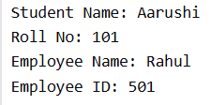  Ans 2  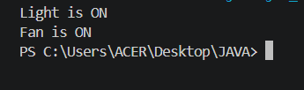
Conclusion | In this experiment, we learnt to implement interfaces for achieving abstraction and multiple inheritance of type.

